**Design two classes:**

1. Holding passport information - **PassportInfo**

2. Randomly generating passport information. – At most 100 unique passport numbers will be created

**Data Fields - All data fields should be private. Except for Passport number, all data fields will have a public getter and a public setter method.**

* **Passport Number**: a **String** field with exactly **9 characters** - **First 'two'** are **Capital letters**, and last **'seven' characters** are **digits** from 0 to 9.

* When each **PassportInfo object is created,** a passport Number is randomly generated using "StringBuilder class"

* **Passport number will be created and assigned when any constructor of PassportInfo is created**. This will have only a **public getter** field. **Setter** field should be **private**.

* **First Name:** A String field containing the given name (First name) of a person.

* **Last Name:** A String field containing the surname (Last name) of a person.

* **NID number:** A String field containing 10 digit NID number. First digit must not be 0, and the field can not contain any other characters except for 0 to 9.

* **Date of Birth:** A field containing month, date and year of the date of birth. Use an appropriate data type, or create your own. You can create your own class for this.

* **Picture:** A two dimensional field (1024 * 768). Each field contains three elements - Red, Green and Blue color value. Each color value can be from 0 to 255. Use an appropriate data type, or create your own. You can create your own class for this.

--------------------------------------------------------------------------------------------------------------------------------------------------------------

**Static Fields - All static fields should be private. Static fields are not object specific, and accessible to all objects.**

**All Passport Numbers:** A static array of 100 passport numbers. When each potential passport number is created - before assigning it to a newly created passport number - it is checked against this array.

If this array already contains this passport number, then a new random passport number is generated. If a unique passport number is generated - it is assigned to Passport Number, and put inside this array. Assume that no more than 100 passport numbers will ever be created. A value inside this array means a Passport with this number has already been created. You can show appropriate console messages in this case.

**All NID numbers:** A static array of 100 NID numbers. Each time a NID is assigned to a passport, if this array does not contain the NID - a new NID is added to this number.

**Methods:**

* 1. Create appropriate getter and setter methods and constructors.
  2. All Constructors should be private. A static method called **Builder()** should create and return a new passport object with a unique passport number.
  3. Create appropriate private or private static methods.
  4. Add **javadoc comments** for each method **created explaining the operation of the method, and what the parameters represent.**
  5. **In the comments section, explain why this method is private or public, and why this method is static or non-static.**
  6. Add a toString method that returns a string containing: **passport information, Full Name, NID and Date of birth in the same line** in an understandable format. Use the StringBuilder or StringBuffer method.

**The class for randomly generating passport info** is called **GenerateRandomPassportInfo.** This class will contain the main method, and other methods to help generate Passport information for 100 users.

* + **For each randomly generated PassportInfo, randomly assign the following information**:
    1. First Name: Should randomly select one of 50 predefined first names.
    2. Last name: Should randomly select one of 50 predefined last names.
    3. Date of birth: Random, Should be between 1940 and 2000.
    4. NID: Random. **Two passports can have same NID.**
    5. Picture: randomly assign pixels at time of creation.
  + **Main method:**
  1. Create 100 random passport holders and hold their information in an array.
  2. Given a NID, use the above array to find and display **one or multiple** passport information containing the same NID. If no NID, then display - “Passport not found”.

**What I understood:**

In the driver class, we need Generate_NID method, Choose_Name method, Birthdate method, and Picture method.

Choose_Name method contains hardcoded 50 names string array, this will be used to assign both First name and Last Name.

Generate_NID method will generate a string using Array and Loop to individually select characters (digits) randomly (with random object function). Arrays.toString will return the created array in string format.

In the main method, we need to create a **PassportInfo object,** and loop it 100 times to create 100 holders.

**Passport Number** is randomly generated using **"StringBuilder"** every time we create a PassportInfo object (should be inside the loop);

Need to create a **StringBuilder method** that we will call inside the loop. - Passport Number*: a String field with exactly 9 characters -* ***First 'two' are Capital letters, and last 'seven' characters are digits from 0 to 9.***

The info we generated in the driver class will be passed to the PassportInfo class using the loop.

**Therefore things we are passing: First Name, Last Name, NID, Passport Number, Birth date, Picture.**

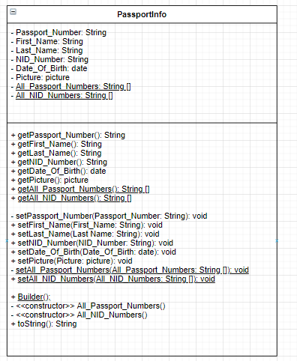

<https://app.diagrams.net/#LCSE%20215%20Assignment%203.drawio>